THE
MEGA AUTORESPONDER SEQUENCE FOR AFFILIATES
This is the SECRET WEAPON for many of our top affiliates
In fact, this list is responsible for generating millions of affiliate commissions for many of our affiliates over the years!
You can get a potential total of over $530 in commission from the entire sequence - from just ONE customer!
This sequence consists of all the woodworking related products you can promote with us (and some not even listed on the Clickbank Marketplace!)
All you need to do is to replace "xxx" with your Clickbank ID and plug these into your autoresponder.
Then simply watch your commissions skyrocket!
Keep getting new subscribers into your list and you can potentially generate HUGE commissions over and over again...
If you're looking for a quality autoresponder, I recommend Getresponse (aff link)
WHAT PRODUCTS DOES THIS SEQUENCE COVER?
This sequence consists of:
- Teds Woodworking
- Ultimate Small Shop
- Wood Profits
- Ultimate Price Guide (sub product of WoodProfits)
- My Shed Plans
- 20 Woodworking Tricks (sub product of Teds Plans)
- Home Woodworking Videos (recurring physical offer coming soon!)
So let's get down to it!
SETTING UP YOUR OPT-IN PAGE
Simply replace "xxx" with your Clickbank ID and plug these into your autoresponder.
To start off, the first email will be to offer your subscribers the lead magnet that you're giving out.
There are a few options to do this.
1. You can give them free plans to download
2. You can give them a free folding picnic/table combo plan
3. You can give them the "Art of Woodworking" book

SAMPLE LANDERS:
Here are some sample landers for the opt-in pages you can build.
We do not provide templates as we encourage affiliates to create their own lander using their own builder of choice.
For simple minimalist pages, you can use WordPress.
If you want an easy-to-use page builder to build these sample sites, you can check out LeadPages
If you want a more complete solution, try ClickFunnels (Free 14 Day Trial)

FREE PLANS LANDER SAMPLE:
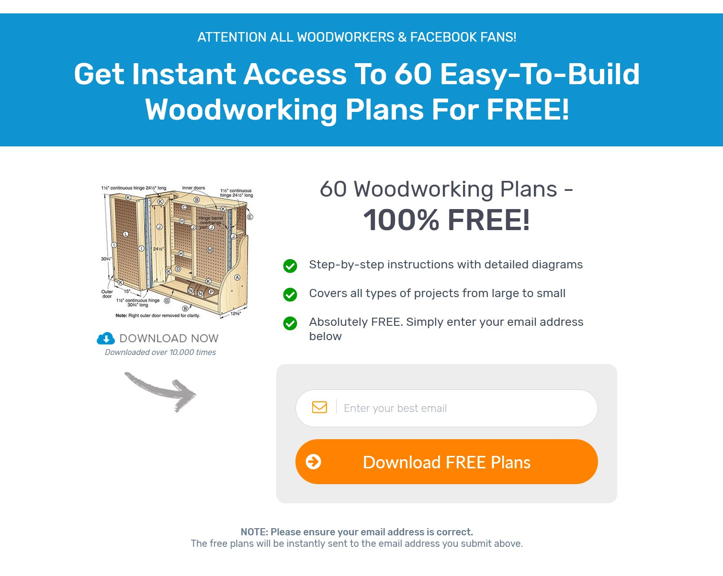
https://topwoodplans.com/gift/

FREE DIY FOLDING BENCH/TABLE SAMPLE LANDER:
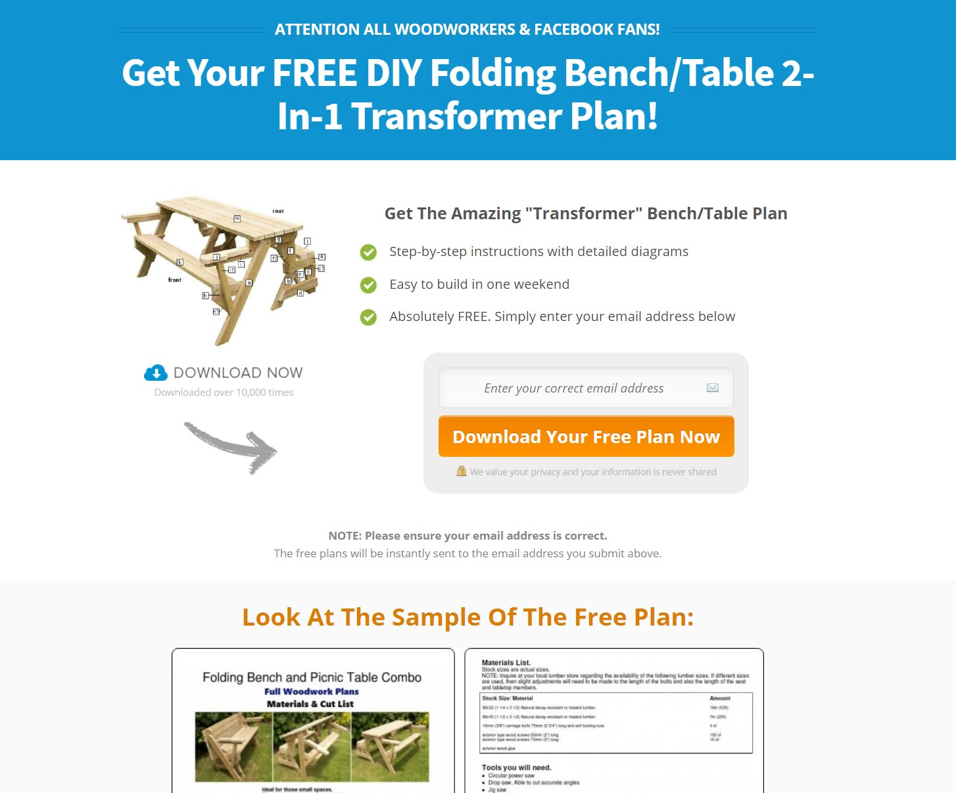
RESOURCES:
http://tedswoodworking.com/FoldingBenchPicnicTable957.pdf
https://tedswoodworking.com/affimages/bench-img.jpg
https://tedswoodworking.com/affimages/picnic-table.jpg
FREE ART OF WOODWORKING + 40 GUIDES SAMPLE LANDER:
RESOURCES:
https://tedswoodworking.com/affimages/art-woodworking-xs1.png
https://tedswoodworking.com/affimages/ArtofWoodworking_40_Projects.pdf

WHAT PRODUCTS DOES THIS SEQUENCE COVER?
These are download pages of free plans and reports.
(just replace XXX with your ID)
2 in 1 Folding Picnic Table Bench Plan:
http://XXX.tedsplans.hop.clickbank.net/?pid=pictable
Modern Side Table Plan:
http://XXX.tedsplans.hop.clickbank.net/?pid=modern
Guide To 13 Wood Joinery Types:
http://XXX.tedsplans.hop.clickbank.net/?pid=joinery
Art of Woodworking Download:
https://hop.clickbank.net/?affiliate=XXX&vendor=tedsplans&pid=artw

EMAIL TEMPLATES
(just replace the blue highlighted links in the email template with your affiliate link)

TEDSWOODWORKING:
YOUR AFFILIATE LINK IS:
https://hop.clickbank.net/?affiliate=XXX&vendor=tedsplans
(just replace all blue text links with your affiliate link in your autoresponder)

EMAIL #1:
Subject: Grab 16,000 woodworking plans here (Open Now)
Subject: Get instant access to 16,000 plans inside
Subjects: 16,000 woodworking projects for a limited time only...

body:
Hey [firstname]
Here is something you'll absolutely love if you're a woodworker.
Get access to 16,000 woodworking plans >>
You can get instant access to over *16,000* woodworking projects in the next 5 minutes or less..
You got to check out Ted's video now
Ted has spent years putting together "Earth's largest collection of woodworking plans!"
I'm talking about 16,000 "done-for-you" plans with STEP-BY- STEP instructions, photos and diagrams to make every project laughably easy...
And the best part is, it doesn't matter if you don't have a large workshop or expensive tools!
Get access to TedsWoodworking now >>

You can download the entire "TedsWoodworking" 16,000 plans package and all the bonuses right now. Plus you'll get the option of getting everything on DVDs.
You can be going through all the plans in just a few minutes from now
Experience the joy.. the satisfaction, to know with 100% certainty that your project will turn out exactly the way you want it to look.
It's an incredible feeling…
...being able to wake up on a Saturday morning and get to work on your project with absolute confidence it will turn out right.
With no strange gut feeling you’ll make a mistake or you won’t finish what you start...
That's the way woodworking is supposed to be.
Click here to take a look at his plans
.
THIS IS A TIME-LIMITED OFFER
Ted is running a time limited "launch discount" and the complete package of plans is 77% off the regular price
This special launch offer will close soon and you won't be able to get in at this price after that even if you want to.
So grab your discount while it lasts...
Don't miss out on this.
Have a great day and talk soon.
Your Name
P.S: Ted's collection of plans are some of the best I've seen. If you're a woodworker, you really don't want miss out on this great deal. (insert aff link)

EMAIL #2:
Subject: I almost gave up on woodworking...
Subject: My emotional story as a woodworker
Hey, it's [YOUR NAME] -
I have an story for you today...
When I first made the decision to build my first workbench, I was completely overwhelmed
I had a copy of a plan to build it but details were lacking and the entire process was so daunting. Needless to say, I struggle to get it built... and I almost gave up on woodworking...
That's when I knew I needed help.
So after I discovered Ted's 16,000 plan collection and it was kind of a no-brainer… and since joining, I’ve been nothing less than amazed at what I’ve been able to build.
I've made furniture (some that's for outside, and some that's never going out of my sight).
The workbench I use on a regular basis is one I built during the course…
If you have that inkling, where you feel like you need to do this, or you're interested in it, or it's something that would spark that flame of creativity in you, don't delay.
Grab your copy of TedsWoodworking 16,000 plans now
Because when you start building, you’re going to surprise yourself with what you create and say, "I can't believe I made that!"
And that feeling is like nothing else in the world.
Imagine building some of these projects below:
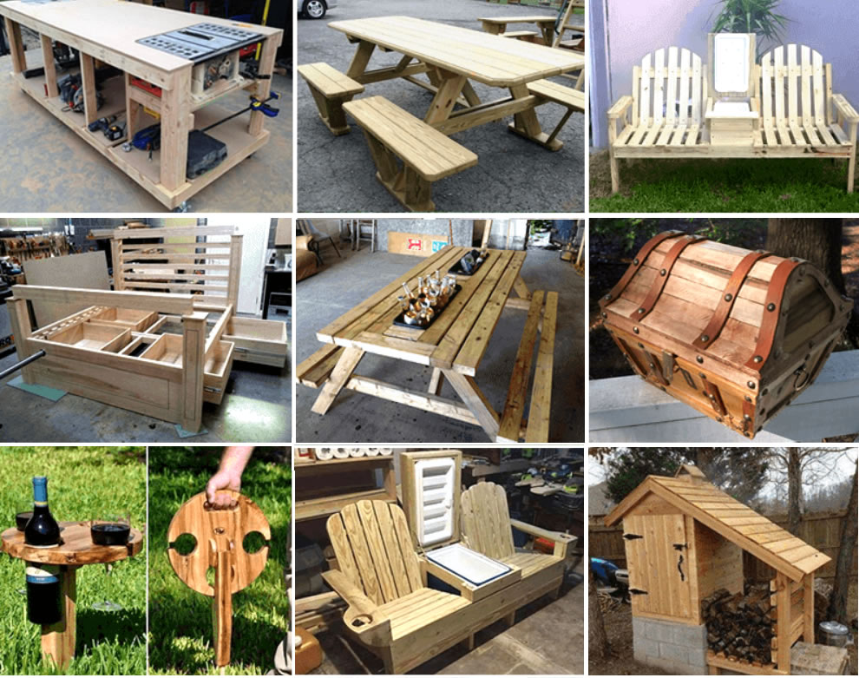
Isn't it amazing?
TedsWoodworking was life-changing for me. And if that sounds like an overstatement, trust me when I tell you, if anything, it's an understatement.
Because in the end, this isn’t just about learning a new hobby...
It’s about helping you connect with that deep inner urge to create, to build something meaningful that will last for years...
So get started with your next project here
And I'll see you on the inside,
(Your Name)
P.S: Imagine having access to a lifetime supply of woodworking plans. How much time, effort and money it would save you?
For the price of a night out, you can take any and all headaches out of building quality woodwork projects - forever!
Click here to get access now

EMAIL #3:
Subject: your questions answered
Subject: here are the questions you asked...
Hi [[firstname]]
Since I've emailed you about TedsWoodworking, I’ve been thrilled with the incredibly positive response it’s received.
Hundreds of woodworkers have already joined and are already building projects easily and quickly with the plans.
If you’re ready to join, just head to the course sign up page: TedsWoodworking Package
In addition to all the kind words and excitement, I’ve also received a lot of questions about the course. So I wanted to take this opportunity to answer some of them here:
=======
1. How do i get access to the plans? Is it something sent to my house?
You’ll get instant access to the package. It’s kind of a membership site, but don’t worry about a monthly membership fee or anything like that.
You will pay only once and that’s all you pay. There’s no additional charges, no hidden charges, no nothing like that.
For a small fee I will also ship worldwide, the DVDs of all the plans and bonuses..

2. Are there a lot of beginner-friendly plans in this?
YES. Most of these plans are beginner plans. With the rest being intermediate and some being expert plans.
But keep in mind, given the quality of these plans, you might surprise yourself with your ability to quickly expand the projects you can do.

3. How long do I have access to the plans?
You have LIFETIME access to all the plans in the members area. Your membership never expires and you can login anytime to download more plans. Whats more, I draft new plans every month so you'll always have new ideas, new projects to make

4. Why a one-time fee? Won’t you lose money long term?
Not really. It is a digital product after all. I suppose if everyone were to get this deal then yeah, eventually the time I spend every month creating the 5 new plans wouldn’t earn me an income. Which is why I am taking this page down soon!

5. I can't afford tools or materials to build my project
If that’s the case… this is perfect for you… because you will learn exactly what you need to build a project you’re interested in. So there’s no wasting your money on tools you won’t use. Just buy exactly what I tell you and follow my instructions. Then move onto the next and buy the new tools you need (if any)… Simple and cost effective!
Simply get what you need for the projects you want to build at anytime. I'll also show you ways to get lumber and materials for far less than what you pay retail.

6. I don't have any space for a workshop.
Fact is, you don't need a large space or expensive tools to build many of the projects. I started off with a 7x8 size workshop and many of my best pieces came from that shop.
I've included many small mobile workbenches you can build right away as well. Many of my plans do not require professional machinery or even a router.

7. Can I sell the projects I make with your plans?
Absolutely. You can sell the projects you build with our plans. Many of my customers went on to make a sizable side income by selling projects they make.
===========
I hope this answers some of your questions. (And, of course, you can find more answers and full course details on the sign-up page.)
By now, I hope you’re also starting to see that, with the right plans, you can create anything out of wood – no matter if you do not have a large shop or years of experience.
So join now and get access to 16,000 plans
I can’t wait to see what you'll build...
See you inside!
– Name
P.S. Don’t forget – the launch offer is closing shortly, so there are only a few more days to sign up.
Join now before the offer expires.

EMAIL #4:
Subject: it might be too late... (open now)
Subject: open this...
Subject: ending in 24 hours...
body:
Hey [[firstname]]
This is important:
Have you secured TedsWoodworking yet?
If not, go immediately to do so...
Click here to get access right now
PRICE IS GOING UP IN 24 HOURS
I've been emailing you about TedsWoodworking on the past few days but the time is almost up to secure your launch price.
Ted is about to remove the special offer shortly and this is your last chance to secure this offer.
As I've said, this is the *EASIEST* way to start your woodworking projects - and it's still at a ridiculous low price:
So join now and get access to 16,000 plans
If you're just starting out or you're a seasoned carpenter, you'll find out just how simple it is to build projects using TedsWoodworking step-by-step plans.
With over 16,000 plans, it covers a ton of projects. Check it out and see why I endorse it so much.
You'll love it.
So hurry and claim your copy...before this offer ends
Take care and talk soon.
Your Name Here
P.S: This is your last chance to get it at the launch price.
Get in now, or risk missing out completely

EMAIL #5: (send 1 day after email 4)
Subject: bad news...
body:
I screwed up.
Yesterday, I sent an email telling you about TedsWoodworking collection of 16,000 plans
Bad news is, I must have underestimated the amount of people who wanted to get in ... because Ted's server actually fell over.
So to those who wanted to sign up (but couldn't) ... I am very sorry you got a '404 page error'.
This is due to an overload of traffic to the webpage that caused it to go down...
However as his way of apologizing, Ted has informed me that he will extend the offer for 1 more day.
For those of you who missed out, click here to access TedsWoodworking now (insert aff link)
Again, this offer will end at midnight tonight.
If you really want to get your hands on 16,000 projects (and I’m guessing you do or you wouldn’t have even visited the site), then you should grab it right now.
Remember, not only will it give you step by step instructions on whatever you're working on, but it will also give you tons of ideas for your next woodworking project.
So order NOW before the discount expires tonight
Thank you for your time and patience. Fingers crossed my servers hold up this time : )
Best regards,
Your Name
P.S: I've been told that Ted will only extend this offer until midnight tonight and this offer will NOT be repeated again.
No pressure or anything but if you miss this out, you'll have to pay full price in future.
Click here to get access to 16,000 plans right now

ULTIMATE SMALL SHOP:
YOUR AFFILIATE LINK IS:
https://hop.clickbank.net/?affiliate=XXX&vendor=usmallshop
(just replace all blue text links with your affiliate link in your autoresponder)

EMAIL #1:
Subject 1: Set up a shop even if you've no money, no space and no tools?
Subject 2: Secret tool source that saves you 70% off prices?
Subject 3: The 3 Deadly "Small Shop" Mistakes (and how to avoid them!)
Hey, its XXX
If you're looking to set up a woodworking shop, you've got to check out this video right now
In Ralph's free presentation, he'll reveal the 3 most common mistakes when setting up shop and how YOU can avoid them!
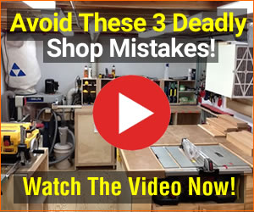
And it doesn't matter if you have no money, tools or space to set up a shop
Because in the presentation, Ralph will reveal a secret tool source that can save you at least 70% off tool prices. (and its not Harbor Freight...)
You'll also discover EXACTLY how to setup a fully functioning workshop for under $1000...even if you do not have a large space.
Watch the free video presentation here >>
To your perfect shop,
XXX
P.S: There's lots of lessons that are invaluable in the presentation so watch it till the end and let me know what you think!
EMAIL #2:
Subject: Set Up Your Workshop Under $1000 (even if you've a small space!)
Subject: Can you set up a small shop for under $1000?

Hey, XXX here again.
A lot of my students has asked if it is possible to set up a shop for under $1000...
Yes, it certainly is possible.
The secret is to know:
• WHAT tools you really need (so you won't waste your hard earned money)
• WHY do you need each specific tool (so you'll get only the tools required for your project)
• WHERE you can buy them at ridiculous prices (discover my secret supplier list...)
That is where Ralph's new guide: Ultimate Small Shop comes in.
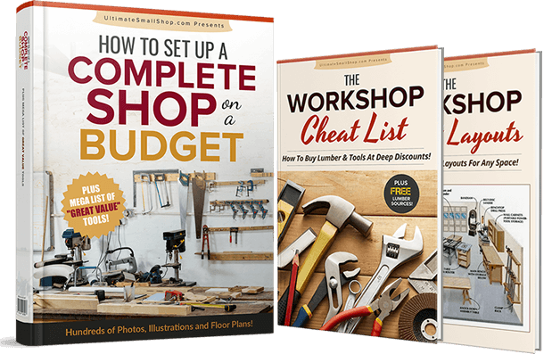
Set up the Ultimate Small Shop for under $1000 here
And the most important part of this guide is:
A List Of The Absolute BEST Tools To Get... and WHERE to Buy Them For The Cheapest Price Possible
Once you have this list… you won’t have to spend anymore of your precious time researching tools… and more than that... you’re going to save yourself hundreds or even thousands of dollars in the long run by buying the best tools from the start.
And inside this guide, you'll discover exactly what to do to set up a functional and well organized shop for under $1000 in a small space....
.... with professional-grade tools and equipment – for up to 60% less than your friends are paying!
Discover how to set up your shop under $1000
Here's what else you'll discover:
• Secret sources for buying dirt-cheap Grade A tools that even the PROs don’t know about. (Amazon, Wal-Mart, Lowes and even Bargain Outlet are charging WAY more for the exact same items!)
• How you can set up a workshop for as little as $1,000… without skimping on quality or “must haves.” (You wouldn’t believe some of the workshops people create with a budget this small!)
• Which tools and machines are absolutely essential to a fully operational workshop where you can create mind-blowing works with ease… and which ones you can do without.(Skip the “ego boosters” and stick to what you need, and you can save $1,000s!)
• How you can turn even a TINY space into an impressive workshop that lets you build whatever you desire. (Forget what those slick woodworking magazines say… smaller really is better!)
• And many more...
In other words... you will find everything you need to build the perfect shop for yourself.
Here's the Bad News:
Ralph's launch offer is ending so the price WILL increase shortly.
If this is something that interests you, check out the video and take action today
And remember, with the 60-day guarantee there is no reason not to give this a shot.
Woodworking is something that has given me so much joy… I know it can be the same for you.
You just have to get over the tool and space roadblocks.
That’s why Ralph has written this wonderfully detailed guide.
And I know you're gonna love it.
Check out Ultimate Small Shop Here
Place your order now... because the price WILL be going up soon.
I’ll see you on the inside,
XXX
P.S: And it doesn't matter if you have no money, tools or space to set up a shop
Because in the presentation, Ralph will reveal a secret tool source that can save you at least 70% off tool prices. (and its not Harbor Freight...)

EMAIL #3:
Subject #1: Real students spill the beans (unedited reviews)
Subject #2: "This saved me quite a small fortune!"
Subject #3: Some amazing feedback from Ultimate Small Shop customers
Hi. It's XXX
Have you ever done something so bold, but didn't know what other people might think?
That's what Ralph told me when he sat down and start writing and compiling his sources for Ultimate Small Shop.
He knew this was the most definitive guide on shop setup, and he would need a group of woodworkers to verify that.
He knew his resources, tips, shop hacks, layouts, tool lists are carefully created and the secret supplier lists will save woodworkers a ton of money.
But when he finally launched this, Ralph had no idea how it would be received.
So each week, when Ralph received photos of beautiful shops (by the hundreds), he was thrilled, impressed, and honestly moved.
Today I want to share with you some of the feedback he shared with me for Ultimate Small Shop

George Hardy says: “I set up my first shop in a spare corner last week with the help of this book and I must say it has helped me considerably. Many of the tools I've bought with the list provided has really saved me quite a small fortune.”
Tim Simmons says: "Money is always an issue, but more important to me is the subject of time. This book solves both aspects for me. It contains sound advice if you do not wish to overspend on your shop."
Marc Berg says: “Many practical ideas for the not-so-rich. Unlike other books I've read, this book has tons of info for folks that don't have cash to burn. There are a lot of great ideas that can be implemented at pretty low cost"
William Wolf says: "In my opinion this book will be invaluable to anyone setting up a woodworking workshop. It walks you thru setup step by step."
And these unedited, real-life reviews are just a small sample of the feedback Ralph received from the over 2,000 students who have read the book so far.
Seeing this feedback gives me confidence that you will enjoy Ultimate Small Shop as well.
Setup your perfect shop under budget here >>

================
A quick recap of what you will discover and more:
• A hand-tool only shopping list if your budget is under $500 (or if you just want to use hand-tools only)… and direct links to buy them for the best price. (pg 41)
• A power tool and hand-tool shopping list if your budget is under $1,000… and direct links to buy them for the best price. (pg 42)
• The 5-second trick that keeps your tools and machines in top working condition. The manufacturers won’t tell you this for a reason! Do this before and after you start working and you can postpone buying replacement parts for YEARS.
• Ralph's secret source for buying tools at HUGE discounts. He once found a Dewalt DW734 12 ½ inch planer for $170 on this site… when Amazon sold it for $399. And NO ONE talks about this place.
• The best (and really the ONLY) items Ralph would recommend buying at big box stores like Home Depot and Walmart.
… and the list goes on because this is only ONE of the SIX modules in this guide.
So get your copy of Ultimate Small Shop now >>
Do remember, the launch price offer is ending very soon...
The clock is ticking, so grab your copy while it lasts.
See you on the inside,
XXX

EMAIL #4:
Subject: [Last Chance] Launch Price Ending...
Subject: Your LAST Chance To Get Ultimate Small Shop
Subject: Launch Price Ends in 12 Hours!
XXX here and I promise this is the last email that I'm going to send you about Ultimate Small Shop that I've been talking so much about.
When Ultimate Small Shop first came out, Ralph set the price WAAYY below where it should have been.
The idea was that he wanted to get it into a lot of people's hands, get a lot of success stories, and then I could put it back up to something more reasonable later.
Since then, he has gathered HUNDREDS of amazing success stories!
But time kind of got away from me and Ralph told me he totally forgot to increase the price.
Well, that time has finally come and you have 12 hours left to grab it
What happens in about 12 hours?
It will still be available but I can't guarantee it will be for the deal you're getting now
So...
You can act now and get it right here and set up your shop for far less than you imagine (all while being protected by the 60 day guarantee)
Or...
You can let the clock decide and miss out.
And after today, you won't hear me talking about it any longer.
So this is your last chance.
If you've ever thought about setting up shop, get in now, or risk missing out completely:
Learn more about Ultimate Small Shop and get your copy now
Go make sawdust!
MYSHEDPLANS:
YOUR AFFILIATE LINK IS:
https://hop.clickbank.net/?affiliate=XXX&vendor=shedplans
(just replace all blue text links with your affiliate link in your autoresponder)

EMAIL #1:
subject: [firstname]], grab 12,000 shed plans inside... (open now)
subject: get access to 12,000 shed plans inside...
subject: Build sheds easily with this collection of 12,000 plans
subject: How to build sheds like lego bricks...

GET ACCESS TO 12,000 SHED PLANS
Hey there,If you enjoy building sheds like I do, here's a great site for you to download shed plans
Get access to 12,000 shed plans >> (aff link)
Plans So Complete, They Build Themselves!
Ryan is giving away over 12,000 step-by-step and easy to build shed plans...with instructions so precise, they practically BUILD THEMSELVES!
It is simply one amazing collection with the largest amount of shed plans I've ever come across...
Download over *12,000* fully detailed shed plans and start building your next shed easily and quickly
But you got to act fast because this is a time sensitive offer.
I've been told by Ryan that his special launch price will end in the next few days.
If you want to build sheds the EASIER and FASTER way, than I urge you to get in while the offer is still available.
Your Name
P.S. If you've any interest in shed building, you owe it to yourself to visit his site. You'll get tons of inspiration simply looking at just a couple of his designs!
Get access to 12,000 shed plans

EMAIL #2:
subject: Check out these super sheds
subjects: 4 super sheds you can build right now...
Hey, its (your name),
Yesterday, I sent you a link to MyShedPlans, so I just wanted to check in with you and see if you had a chance to go through it yet...
One of the reasons why I love Ryan's offer is the fact that it makes building sheds as easy as "lego bricks"
In other words...
You'll never need to worry about cutting the wrong size, spin in circles or waste time trying to figure out what goes where...
With Ryan's detailed shed plans, it makes building sheds a breeze - just like putting lego bricks together!
Check out these sheds you can build in a weekend or less:
If you'd like some help doing this yourself, I'd recommend checking out MyShedPlans 12,000 plans package
You'll be able to create the kind of shed, your neighbors and other woodworkers will secretly ENVY (while mumbling “nice job” under their breath)...
See what I mean here
If you're really serious about building sheds without the overwhelm, confusion and frustration, then this is your ideal first step.
Ryan's plans covers every single thing you need to build an impressive new shed that will get the awe and respect of the most seasoned woodworker.
But you have to see them to appreciate what he has put together for you.
Click here to access 12,000 shed plans now
This low price is only for a limited marketing test, so it won't be available for much longer.
If you're even the slightest bit interested, I would grab it now while you still can and while it's still fresh in your mind.
See you on the inside!
(NAME)

EMAIL #3:
subject: Last chance? Don't miss this out...[[firstname]]

Yesterday, I share with you a link to 12,000 shed plans you can download immediately
Now if you really want to build amazing sheds easily and quickly (and I'm guessing you do), then this is the only resource you'll need.
It's time to stop letting home improvement stores rip you off with OVER-PRICED kits and time to start taking matters into your own hands...
Click here to access 12,000 shed plans now
UPDATE: Ryan has also informed me that orders are coming in thick and fast so the offer price will end at midnight tonight.
======================================
The Offer: Ends MIDNIGHT Tonight
======================================
Regular price: $97
Special price: $37
Don't miss out on this because Ryan will bump his 12,000 shed plans package to the price of $97 tomorrow.
This is probably your LAST chance to get in at the discount.
Get started right now
Your Name
P.S: I've used Ryan's plans to build my own 10x12 storage shed last week for my family..
It is simply one amazing collection with the largest amount of shed plans I've ever come across...
>> Check out all 12,000 shed designs now << (aff link)

WOODPROFITS:
YOUR AFFILIATE LINK IS:
https://hop.clickbank.net/?affiliate=XXX&vendor=woodprofit
(just replace all blue text links with your affiliate link in your autoresponder)

EMAIL #1:
Subject line: Make money with your woodworking skills!
Hi [[firstname]]
If you'd like an easy way to earn part-time
income by doing something FUN, go check out WoodProfits now
My friend Jim, has successfully run a HIGHLY
profitable woodworking business from home
and he has just released his step-by-step blueprint.
Read his amazing story here
It is a no-fluff step by step guide to create a part-time woodworking business, selling easy-to-build wood crafts, from HOME...with little to no capital
He started out with little carpentry skills and run a business in a 10x20 feet space with almost nothing...
And managed to made $9000 per month as a one-person business within the FIRST year! See how you can also do it...
The cool thing is, you don't have to be an expert woodworker to start this business as it's packed with solid
STEP-BY-STEP instructions and information on what to do to turn your *passion into profit*.
Click here to find out more
Act on this quickly before the door shuts as the offer may be taken down very soon...
Hope this helps
Your Name
P.S: The *one-on-one* coaching Jim provides is worth much more than the entire package.
I think he's crazy to offer that at the price but go check it out and judge for yourself:

EMAIL #2:
Subject line: The most underrated teacher on the planet?
I’m not a fanboy of a lot of people
But, one teacher I’m an unrepentant fanboy of is Jim Morgan.
Jim is (IMHBAO) the most underrated marketing mind on the planet, especially when it comes to woodworking businesses.
Example?
Okay, how ‘bout these mangoes:
Years ago (2012) Jim gave a presentation at a tradeshow that completely revolutionized the way I do business.
I remember hearing carpenters doing $100k+ per year in absolute awe at Jim's methods which include:
- Setting up a woodworking business from home and be profitable from the very first month
- Getting a list of high-margin, easy to sell, profitable niche crafts you can build using BASIC woodworking tools
- The Porcupine Theory" that lets you find customers who are "in heat" for your product...
- How to tap into the "cycles" of frenzied buying most markets go through
- Twelve words that will literally "force" people who have bought from you once... to buy from you again
This info is invaluable.
The best part is, it still works today.
And, I use many of his methods all the time.
It's pretty much what l transformed my business
He compiled everything in his new book: WoodProfits - How To Launch A Home Based Woodworking Business
Anyway, it’s easily one of the best book I've read on woodworking businesses
Yet, hardly anyone knows about it.
In fact, if you asked 1000 woodworkers if they’ve heard it, I doubt more than 4 or 5 would know what you’re talking about.
And, unless you were there or have the CD’s of that particular presentation well, good luck finding it.
That’s the bad news.
The good news?
I made a deal with Jim where, if you get his digital book, he'll throw in a bonus entitled: 500+ Top Selling Crafts & Furniture Plans. It contains over 500 plans of his top selling crafts.
And yes, there is a catch:
This bonus together with his discounted offer ends in a few days time.
Click here to grab your copy now
Name

EMAIL #3:
Subject line: How to get your customers naked
Body:
One of the big mistakes people make when selling their woodworking crafts, especially to strangers, is they don’t make it comfortable for people to get "naked."
They know how to create simple crafts. But, they don’t do know jack about selling
Taking the dating analogy:
Consumption is based on comfort.
If they feel comfortable with you, they go naked.
If not, they don’t.
This is what customers do, too. People don't go naked in front of other people until they're comfortable with them.
Customers buying your products are going naked. They're putting their trust in you. It's not just a game that you're playing.
What?
The dating/secks analogy offends your delicate psyche?
Okay, then look at the buffet.
If you’ve been to a buffet you’ve never been to, what's the first feeling you get?
Intimidation, probably.
“What am I going to eat first?”
“Where do I start? The salad bar? The dessert tray? What is really tasty? What's really important? What's not important? What…?”
Obviously, if you fill your plate full of gunk, and you start eating it, you don't feel like throwing it away, so then you fill yourself on gunk and then you don't go back for the really good stuff.
You don't know what's important and you don't know what's not.
Then you end up like a stuffed turkey.
You go in there expecting, “Wow, I'm going to get all this food.” Then you go, “I’m never going to go back there,” at least for a year, or at least six months.
Something else about buffets:
Notice they are almost always cheap and all you can eat.
All that food for a low price.
Yet, most people have a much better experience, paying a lot more money, for a lot less food, at a regular restaurant where they’re taken through a *sequence* (seated, appetizer, main course, dessert, coffee, drinks, etc).
So much psychology to this.
Most of it never talked about — especially by "experts"
And that is why I’m so passionate about the WoodProfits system. There just ain’t anything else like it that has had such a dramatic impact on what I sell and how I sell.
If you want this forbidden knowledge, here’s what you should do
Click here to get the copy of WoodProfits
You'll get the entire system, strategies and tips to start your own woodworking business from home... with a minimum amount of capital
You'll also get 500+ top selling plans as a bonus, so you'll never run out of projects to sell.
This offer ends will end shortly
So if you want it, best hurry.
Here’s the link:
WoodProfits Home Based Woodworking Business
Name

EMAIL #4:
Subject line: [firstname], open this NOW...
Body:
Hi [[firstname]]
Yesterday, I told about about Jim's WoodProfit course.
I've spoken on the phone with Jim Morgan and I've been told that the offer will be taken down tomorrow.
Now if you want earn some pocket money during this
recession and run an easy to start and fun business,
you'll LOVE this guide.
So grab your copy before the offer ends.
===============
URGENT UPDATE:
===============
I've also been told by Jim that there's only *8* slots left
for the free bonus and one-on-one coaching.
Once he fill up these last 8 spots, I can assure you
it will not be repeated.
So I urge you to get the bonus and be among the 8 people:
Click here to get the copy of WoodProfits
Your Name
P.S. My favorite section of the guide is where Jim gives you 500 of his TOP- SELLING wood crafts. This is really the "golden-goose" for woodworking businesses.
Check it out right here

20 WOODWORKING TRICKS:
YOUR AFFILIATE LINK IS:
https://hop.clickbank.net/?affiliate=XXX&vendor=tedsplans&cbpage=20tricks
(just replace all blue text links with your affiliate link in your autoresponder)
=================================
This is a sub product of TedsWoodworking, unlisted in the marketplace!
The main product costs $17 - and you get 75% of it. It also has 3 upsells and 2 downsells in the funnel.

EMAIL #1:
SUBJECT: 20 ingenious woodworking tricks...

Hey [[firstname]]
Now if you want to build and complete projects far easier and quicker than you've thought possible, check out these 20 ingenious tricks the pros use
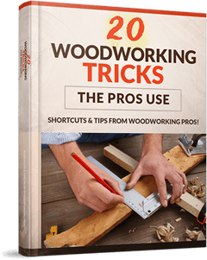
In my new book, you'll discover 20 "shortcuts"... either to save time or make woodworking much easier
- Shortcuts that'll help you to complete any project perfectly... in the shortest amount of time
- 20 tricks that will make you go "aha! why didn't I thought of that before!"
The best part is these are simple, smart and straightforward.
A new simpler way to do something you might have done a hundred times before.
Tricks that'll make woodworking easy and effortless... whether you are an accomplished woodworker or just beginning to set up your workshop
The good news is, since you're a subscriber, you can have the new book for a "special subscribers only deal"
The bad news is I don't intend to keep this low price forever
So, check it out here before the price get raised
Name

EMAIL #2:
SUBJECT: Discover the secrets of master woodworkers...

Not many people know this...
Many moons ago, I dropped out of school for a woodworking apprentice course.
I wanted to be just like grandpa, a master craftsman... who has made his fortune with woodworking.
My family and friends thought I was bonkers…
But I knew I was on the verge of something great… just you wait till I have a thriving carpentry business… and a life you’re going to envy…
Then, when I finished my first project
… it was terrible.
And I struggled for many years with woodworking after that...
But the thing I discovered is... it wasn't really my fault.
You see, a lot of advice from "experts" make woodworking more complicated than it need to be...
It's no wonder that most beginners get overwhelmed when presented with the typical "expert" advice that requires you to learn 10 new techniques… and have the skills of a master craftsman...
That’s why, inside "20 Woodworking Tricks", I give you just 20 simple tricks that'll make woodworking simple and effective
When you make things simple, they become…
- Easier to understand
- Easier to execute perfectly
Here's what you can discover:
- The Triangle Method: The best way to layout wood for efficient woodworking to cut down 50% of planning time.
- The simple (but often overlooked) way to mark cut lines to save time - a great habit to fall into!
- A simple "drill bit hack" that gives you perfect holes every time. (the hack that all manufacturers should include but they NEVER do... I'll tell you what it is on page 7...)
- Clamp ANY angle with this nifty jig that costs less than $1
- And the list goes on...

Many of these tricks are learned from masters of the craft or my own experience of 25 years.
Techniques that I've used over the past 25 years to complete multiple projects in day... without expensive tools, a large shop or anything fancy.
And I'd like to share them with you.
Which is why I'm giving you an insane time limited subscribers discount for my new book.
Instead of $49, you can get it right now for only $17.
I’m sure you’ll agree – that’s an amazing price.
Heck, it’s less than it costs to buy a couple of soggy Big Macs and a few rolls of toilet paper.
Get your copy here
Name
P.S: Check out my tip in a few days called "Why random orbit sanders suck (and how to properly sand wood!)"... in it you'll discover the proper way to sand wood like the pros.

EMAIL #3:
SUBJECT: Why random orbit sanders suck (and how to properly sand wood!)

Woodworking success is mostly about doing the right things, in the right order, in the right way
...and this applies particularly to sanding wood.
If you can see marks left behind on your wood by the planer, begin sanding with a 100- or 120-grit abrasive in a belt sander.
If your wood is already smooth to the eye before sanding (or if you’ve completed sanding with the belt sander), move on to some 120-grit sandpaper in a half-sheet sander.
I much prefer this kind of tool to the very common random orbit sander.
Why?
Random orbits work quickly, but often leave unsightly swirl marks.
A quarter-sheet finishing sander with a 180-grit abrasive is the next best step. It gets you almost all the way.
Finish up with a final hand sanding in the direction of grain using 220-grit paper before finishing.
This ordered, multi-step approach to sanding really works!
Go try it and tell me your results
Speaking of doing things the right way, my guide 20 Woodworking Tricks will show you 20 simpler and smarter woodworking techniques
Get your subscribers discount here while it lasts

ULTIMATE PRICE GUIDE:
YOUR AFFILIATE LINK IS:
https://hop.clickbank.net/?affiliate=XXX&vendor=woodprofit&cbpage=priceguide
(just replace all blue text links with your affiliate link in your autoresponder)
=================================
This is a sub product of WoodProfits and it is unlisted in the marketplace! The main product costs $29 - and you get 75% of it. It also has 2 upsells and 1 downsells in the funnel.

EMAIL #1:

Subject: 3 Simple Ways To Price your Work
Hey, this is xxx
One of the questions that always get asked is "how much do you price your work?"
And like all things in woodworking, there are many “correct” ways to get the job done.
And no, taking 2X or 3X the material cost is not good enough. Wood can vary in price from $1/bf to $50/bf, so you can see how that system falls apart quickly.
If you want more detail, Jim has written an guide called "Ultimate Pricing Guide for Woodworkers

There are basically three schools of thought in regard to pricing non-mass produced work:
- The " Four Quarters " school,
- the " What Does it Cost? " school, and
- the " What is it Worth? " school.
Nearly all mass-produced work I know of uses the "Cost" method to set an initial starting price, then pads the price according to demand.
The " What is it Worth? " school of thought takes very little number crunching but lots of research into your target market. If there are others producing a product similar to yours, you can shoot for a similar price. If your product is unique, then you will have to do some experimentation to figure out what price the market will bear. And you must keep in mind that "value" is a relative concept.
One pitfall to beware of is posting a low price thinking that this will make it more attractive to a larger number of people. If your product is a common item and several competitors offer a similar item, then yes, offering a slightly lower price than your competition can pull their customers to you. But if the price cut is too deep, or if it is a more artistic piece, this tactic can backfire.
The " What Does It Cost? " school goes about it just the other way around.
Here you figure out what it costs you to make an item, what you must add as your profit and set the price accordingly. Less guesswork, and no pretentiousness, but it takes lots of number crunching. For one thing you must account for everything consumed in making your product, not just wood and screws.
Include all basic shop supplies, electricity, water, and heat for your workshop. Don't forget fees for sharpening blades and bits as well as occasionally replacing bits and blades and buying replacement parts for your tools. These are all Cost Of Goods Sold. (COGS to the accountants among us.)
Then you must figure out how much you need to be taking home every month to pay the household bills: this is your projected labor budget. Add labor costs to the materials costs by figuring how many hours of labor you invest in that product and you're almost there.
Those are the costs. Now you need to decide how much you need as profit to keep your company not just solvent but growing.
If that is too much math for you, you may want to try the " Four Quarters " school of pricing.
With this you say that no more than 1/4 of the item's cost will go to materials, 1/4 to overhead (this covers utilities, insurance, tools, etc.), 1/4 goes to labor and the final 1/4 is company profit. This way instead of projecting all the costs, you set a budget and find ways to stay within that budget.
Speaking of pricing, my friend Jim has launched a new book called "Ultimate Pricing Guide For Woodworkers"
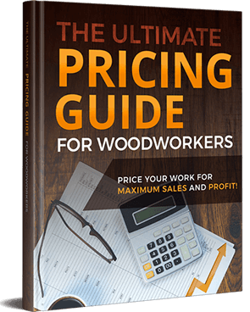
You'll get in-depth strategies with pricing all types of projects and how to maximize your profits.
To see if it’s something that can help you, click here to check it out now
Hope that helps,
xxx
P.S: Pricing is a lot easier than you think. And with my guide, a lot more profitable too.
Get more info here

EMAIL #2:
Subject: People love your work... until they have to pay for it
How much do you agree with this sentence?
Truth is, some people think that woodworkers should just "donate" all of their time, skills & hard work.
They go something like, “well, this person loves what they do… so they shouldn’t be charging so much for their time.”
But skilled labor isn't cheap and cheap labor isn't skilled!
In this new guide "Ultimate Pricing Guide For Woodworkers", Jim will show you how to overcome this objection and not only that, convert these skeptics into customers...by knowing how to price and position the right way.
Lets face it. One of the hardest things to figure out when as a woodworker is exactly how much to charge.
Not even just how much to charge:
• but how to charge…
• how to figure out your prices for work…
• how to maximize your sales & profit…
• and how to avoid some typical new woodworking business mistakes.
All of that (and more) is covered in Jim's new book “Ultimate Pricing Guide For Woodworkers”.
It takes a “Deep-Dive” into pricing your work.
You'll also discover:
- How to eliminate the “compete on price” mentality that keeps even seasoned woodworkers from charging what their skills are really worth
- A secret way to discover the exact "magic" price that will work best for whatever you are selling!
- How to draw ideal customers to you – customers who don’t care how much they spend on your works – without having to spend a fortune on marketing and advertising!
- How to create a crystal-clear picture of an item’s value in your customer’s mind… so that they’ll realize the item is worth more money BEFORE they even ask you the price!
- Over 215 pages of battle-tested, proven strategies and insights to maximize your profits and sales...
Click here to find out more
Here’s to your success,
xx
P.S. Jim's guide also covers detailed pricing strategies for all types of projects, including small crafts, antiques, furniture, cabinets and more...
Grab his new book while it's on a discount now

EMAIL #3:
Subject: A "deep-dive" into pricing your work
This is just a quick follow up to the email I sent regarding “Ultimate Pricing Guide For Woodworkers”.

The sales have been going through the roof, and the feedback has been phenomenal.
Pricing your woodworking projects accurately, being profitable, and setting your shop rate are very important parts of running your woodworking business...
Even if it's just a hobby.
But, if you’ve never run a woodworking business before…
Or are uncomfortable “talking numbers” with people…
Or you don’t have a clue what pricing ballpark to start at…
Then Jim's book, “Ultimate Pricing Guide For Woodworkers” will help you with that.
You’ll also discover:
• How to use the age-old "pile-on" technique to boost perceived value... and thus... get your customers to pay 800% more than anyone else could get them to spend!
• You’ll learn when (and how much) to raise your prices using the 80/20 formula so that you can increase your profitability and keep more of what you make!
• The simple 1-second mindshift that will put pricing into perspective, giving you the power to price every single piece you make with laser precision… and sell it fast!
The proven 3-step process for getting 70%... 80%... even 90% of your customers to buy over and over again… and to refuse to buy from any of your competitors!
The insider secrets to getting a steady stream of referrals who are ready to buy from you!
• And a whole lot more!
It’s exactly what you need if you want stop “guess-timating” prices… and never leave money on the table again.
Jim has put everything he has learned – every pricing and positioning trick, strategy, “hack,” and technique that allowed him to skyrocket his custom cabinetry business after years of trial and error – into one complete, easy-to-follow blueprint.
Check out “Ultimate Pricing Guide For Woodworkers” here
In any case, the 50% launch special will end anytime soon. The clock is ticking...
Here's to your success,
xxx
P.S. It also comes with a 60 day money back guarantee.
If you don’t agree that this guide is everything Jim promised you it would be (and then some)… let me or Jim know within 60 days so he'll refund every single penny of your $29 investment.
Grab his new book while it's on a discount now

HOME WOODWORKING VIDEOS:
** COMING SOON! **

